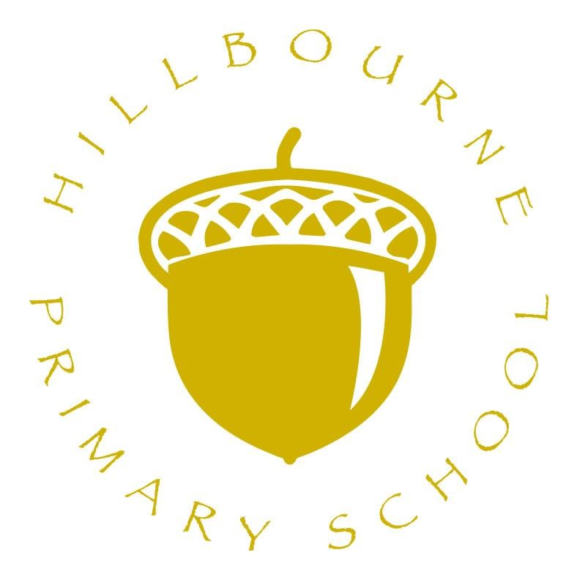

Phonics and Early Reading Policy
2025 - 2027

Date of last review: September 2025 Date of next review: September 2027
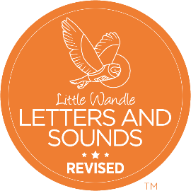

Intent

Phonics (reading and spelling)
At Hillbourne Primary School, we believe that all our children can become fluent readers and writers. This is why we teach reading through Little Wandle Letters and Sounds Revised, which is a systematic and synthetic phonics programme. We start teaching phonics in Reception and follow the Little Wandle Letters and Sounds Revised progression, which ensures children build on their growing knowledge of the alphabetic code, mastering phonics to read and spell as they move through school.
As a result, all children will be able to tackle any unfamiliar words as they read. At Hillbourne Primary School, we also model the application of the alphabetic code through phonics in shared reading and writing, both inside and outside of the phonics lesson and across the curriculum. We have a strong focus on language development for our children because we know that speaking and listening are crucial skills for reading and writing in all subjects.

Comprehension
At Hillbourne Primary School, we value reading as a crucial life skill. One of our utmost goals is that by the time children leave us, they read confidently for meaning and regularly enjoy reading for pleasure. Our readers are equipped with the tools to tackle unfamiliar vocabulary. We encourage our children to see themselves as readers for both pleasure and purpose.
Because we believe teaching every child to read is so important, we have an Early Reading Leader who drives the early reading programme in our school. This person is skilled at teaching phonics and reading, and they monitor and support our reading team, so everyone teaches with fidelity to the Little Wandle Letters and Sounds Revised programme.

Implementation
Language and nursery rhymes in Reception
- Research tells us that nursery rhymes can support children to develop their language, their awareness of sounds within words and even their later reading (Bryant et al. 1989).
- We use the Little Wandle Rhyme time films and accompanying phonological awareness planning to complement and reinforce our Phase 2 teaching.

Daily phonics lessons in Reception and Year 1
- We teach phonics for 30 minutes a day. In Reception, we build from 10-minute lessons, with additional daily oral blending games, to the full-length lesson as quickly as possible. Each Friday, we review the week’s teaching to help children become fluent readers.
- Children make a strong start in Reception: teaching begins in Week 2 of the Autumn term.
- We follow the Little Wandle Letters and Sounds Revised expectations of progress:
  - Children in Reception are taught to read and spell words using Phase 2 and 3 GPCs, and words with adjacent consonants (Phase 4) with fluency and accuracy.
  - Children in Year 1 review Phase 3 and 4 and are taught to read and spell words using Phase 5 GPCs with fluency and accuracy.

Daily Keep-up lessons ensure every child learns to read
- Any child in Reception and Year 1 who needs additional practice has daily Keep-up support, taught by a fully trained adult.
- Keep-up lessons match the structure of class teaching, and use the same procedures, resources and mantras, but in smaller steps with more repetition, so that every child secures their learning.

Daily phonics and spelling in Year 2
- Year 2 begins by using assessment to ensure that children have completed the Little Wandle Year 1 progression. Any gaps in teaching are addressed through daily phonics lessons until the programme is completed. Corresponding summative assessments are carried out to ensure this content is secure.
- Once all the Year 1 content has been taught and assessed, we teach a five-week Phase 5 review. This ensures that children secure the trickier elements of Phase 5 and can apply this alphabetic knowledge in both reading and spelling. We also assess our children after teaching the phase 5 review.
- Once the Phase 5 review is secure; we teach the Bridge to Spelling before moving to the Spelling units.
- Children with larger gaps in their phonic knowledge than their peers have daily phonics teaching and follow the Rapid Catch-up programme.

Children in Year 2 to Year 6: Rapid Catch-up
- We timetable daily phonics lessons for any child in Year 2 and above who is not at age-related expectations for reading or has not passed the Phonics Screening Check. These children urgently need to catch up, so the gap between themselves and their peers does not widen.
- These short, sharp lessons last 15 to 20 minutes daily and have been designed to ensure children quickly catch up to age-related expectations in reading.
- We assess children who are new to our school, new to the country or new to English using the Rapid Catch-up assessments to quickly identify their needs.
- We use the Rapid Catch-up assessments to identify the gaps in children’s phonic knowledge and teach these using the Rapid Catch-up resources – at pace.
- We assess children every four weeks using the Rapid Catch-up summative assessments to assess progress and inform teaching.

Teaching reading: Reading practice sessions three times a week
- We teach children to read through reading practice sessions three times a week. These:
- are taught by a fully trained adult to small groups of approximately six children
- use books matched to the children’s secure phonic knowledge using the Little Wandle Letters and Sounds Revised assessments and book matching grids
- are monitored by the class teacher, who rotates and works with each group on a regular basis.
- Each reading practice session has a clear focus, so that the demands of the session do not overload the children’s working memory. The reading practice sessions have been designed to focus on three key reading skills:
- decoding: teaching children to use phonic knowledge to read words
- prosody: teaching children to read with understanding and expression
- comprehension: using dialogic talk to help children to understand the text.
- In Reception, these sessions start in Week 4 of teaching. Initially, children will read wordless books. In these sessions, children review GPCS and are taught blending using teacher-led blending. Once children can blend, they progress onto decodable books matched to their secure phonic knowledge.
- Children read each book three times to develop phonemic awareness, vocabulary and comprehension, as well as book behaviours.
- In Year 2, we ensure children complete reading the core programme decodable books (up to Phase 5 Set 5). To exit the programme, we complete the final fluency assessment to ensure children can read with adequate speed and accuracy: approximately 60 words per minute with 90%+ accuracy.
- Reading in Rapid Catch-up lessons mirrors the core programme. Children following the Rapid Catch-up programme are taught to read using the 7+ fully decodable books. These follow the same progression as the core programme but are more appropriate for older readers.

Teaching reading: Fluency programme
- We teach reading to children in Year 2 who have exited the core programme using Little Wandle Fluency.
- Each Fluency reading lesson is 20 minutes. The structure of every lesson is the same:
  - A pre-read to practise reading words and to support vocabulary
  - Children read aloud for ten minutes and the teacher ‘taps in’ to hear every child read
  - Focussed teaching of prosody, repeated reading and comprehension through discussion.
- We assess reading speed and accuracy every 12 weeks and use these assessments to monitor progress and allocate books.
- We also use Assessment for Learning (AfL) and our professional judgement to assess each child’s progress in reading, so we can ensure that they have the right books to meet their needs.
- We review children’s prosody by using the Prosody grid. This gives us a picture of how well the child is reading aloud.
- Comprehension is taught through dialogic talk and teachers use their AfL to quickly address misconceptions and develop children’s curiosity and engagement with each book.

Home reading
- The decodable reading practice book is taken home to ensure success is shared with the family.
  - Reading for pleasure books also go home for parents to share and read to children. We share the research behind the importance and impact of sharing quality children’s books with parents through workshops, leaflets and the Everybody read! resources.
  - We use the Little Wandle Letters and Sounds Revised parents’ resources to engage our families and share information about phonics, the benefits of sharing books, how children learn to blend and other aspects of our provision, both online and through workshops.

Additional reading support for vulnerable children
- Children in Reception and Year 1 who are receiving additional phonics Daily Keep-up sessions read their reading practice book regularly to an adult in school.
- We prioritise children who may not have reading support at home or who may not have access to books. We aim to provide opportunities for individual reading times with volunteers and staff to share quality children’s literature to promote a love of reading.

Ensuring consistency and pace of progress
- Every teacher in our school has been trained to teach reading, so we have the same expectations of progress. We all use the same language, routines and resources to teach children to read so that we lower children’s cognitive load.
- Weekly content grids map each element of new learning to each day, week and term for the duration of the programme.
- Lesson templates, Prompt cards and How to videos ensure teachers all have a consistent approach and structure for each lesson.
- The Reading Leader and SLT use checklists and templates to regularly monitor and observe teaching; they use the summative data to identify children who need additional support and gaps in learning.

Ensuring reading for pleasure
‘Reading for pleasure is the single most important indicator of a child’s success.’ (OECD 2002)
‘The will influences the skill and vice versa.’ (OECD 2010)

We value reading for pleasure highly and work hard as a school to grow our Reading for Pleasure pedagogy.
- We read to children every day. We choose these books carefully as we want children to experience a wide range of books, including books that reflect the children within our school and our local community as well as books that open windows into other worlds and cultures.
- Every classroom has an inviting book corner that encourages a love for reading. We curate these books and talk about them to entice children to read a wide range of books.
- In Reception, children have access to the reading corner every day in their adventure time and the books are continually refreshed.
- Children from Reception onwards have a home reading record. The parent/carer records comments to share with the adults in school and the adults will write in this on a regular basis to ensure communication between home and school.
- As the children progress through the school, they are encouraged to write their own comments and keep a list of the books/authors that they have read.
- Children earn Reading Badges as rewards for reading at home.
- The school library is made available for classes to use at protected times, and children have the opportunity to take a library book home to read for pleasure.
- Children across the school have regular opportunities to engage with a wide range of Reading for Pleasure events (book fairs, author visits and workshops, national events etc).

Impact

Assessment
Assessment is used to monitor progress and to identify any child needing additional support as soon as they need it.
- Assessment for Learning (AfL) is used:
  - daily within class to identify children who require Daily Keep-up support, as well as words and GPCs that need additional teaching
  - to plan repeated practice throughout the day to ensure all children secure learning
  - weekly in the Friday review lesson to assess gaps, address these immediately and secure fluency of GPCs, words and spellings.

- Summative assessments are uploaded onto the Assessments tracker for Reception and Year 1. These are used:
  - to generate visual reports (pupil heatmaps, pupil trends and books levels, and a summary analysis) for individual children, classes and whole year groups
  - by teachers, Reading Leaders and SLT who drill down and look at the data at GPC, word, tricky word and sentence level
  - by SLT to scrutinise and plan how to narrow the attainment gaps between different groups of children and to put in place any additional support for teachers.

We assess:
  - every six weeks to assess progress and to identify gaps in learning that need to be reviewed or retaught
  - to establish if learning is secure for more than 70% of children before new content is taught
  - to identify any children needing additional support and to plan the Keep-up support that they need

Every three weeks we reassess every child who is not on track and accessing daily keep-up support in Reception and Year 1.

- Fluency assessments measure children’s accuracy and reading speed in short one-minute assessments. They are used:
- in Year 1 and Year 2, when children are reading the Phase 5 Set 3, 4 and 5 books
- with children following the Rapid Catch-up programme in Years 2 to 6, when they are reading the Phase 5 Set 3, 4 and 5 books
- to assess when children are ready to exit their programme
- for children in Year 2 who are taught Little Wandle Fluency. These assessments identify the best Fluency book level for each child. We assess the children every term (every 12 weeks or so).

- A placement assessment is used:
  - with any child new to the school in Reception and Year 1 to quickly identify any gaps in their phonic knowledge and to plan and provide appropriate extra teaching.

Statutory assessment
- Children in Year 1 sit the Phonics Screening Check. Any child not passing the check
resits it in Year 2.
- It is administered during the summer term by a familiar adult. The check involves pupils reading 40 words- 20 real words and 20 pseudo words.
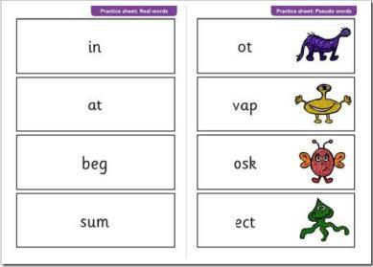

Monitoring and Review
The monitoring of this policy will be the responsibility of the Early Reading Leader in conjunction with the Leadership Team. This policy will be subject to a formal review every three years or sooner if significant changes occur.

Links with other policies
For specific details about possible related practice refer to the following policies:
- Teaching and Learning
- Assessment Policy
- Marking and Feedback Policy
- SEND policy
- Equal Opportunities

This policy will be reviewed bi-annually by the Early Reading Leader and Leadership Team to ensure it remains compliant with statutory guidance and reflects best practice.

